READ FIRST!
NATOPS Instrument Rating Request walk through:
What you need to start:
- Flight Log Book
- The electronic draft of the Request and Excel worksheet: On the share drive
S:\HT_18_Main\HT_18 All Hands\Logs & Records\Inst Check
- Open it Via “Read Only” then save a new copy in your personal folder. Do not save over the master!
When opening the folder online there are two tabs. One of the Excel calculator and the other is the actual request. This Excel calculator will do a number of things. It will add the hours and approaches together, make sure you have the required hours and approaches, a nd transpose these numbers to the request on the following tab. Follow the steps below.
- Input your name, rank, if you are a SNA or IP, and current date.
- From your Log book
  - Input your first flight, this is normally the first flight of Primary flight training.
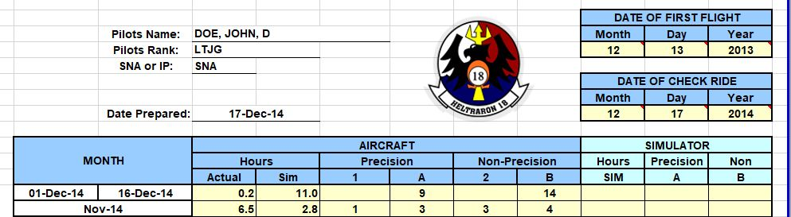
  - The date of the Inst Check.
- The date of your check ride will populate the appropriate months. Next, find the date ranges in your Log Book and input the respective hours and approaches. Aircraft and simulator hours and approaches may reach back as far as Primary flight training, these still count!

  - Actual Instrument Conditions: Conditions external to the aircraft in flight that do not permit visual reference to the horizon.
  - Actual Instrument Approach (1 or 2): When actual instrument conditions are encountered below 1,000 feet above the airport/flight deck elevation during an instrument approach.
  - Simulated Instrument Conditions: Conditions external to the aircraft in the flight are VMC, but pilot vision is limited primarily to the interior of the aircraft.
  - Simulated Instrument Approach (A or B): An instrument approach flown under simulated instrument conditions.

- As seen below, the hours and approaches have been input.

  - In the orange boxes, make sure that there is “NONE” in every box. A number in that box will mean that more approaches or time is required.
- If you have previous Inst time, more than 12 month ago. Place those times in the respective boxes indicated by the blue arrows.
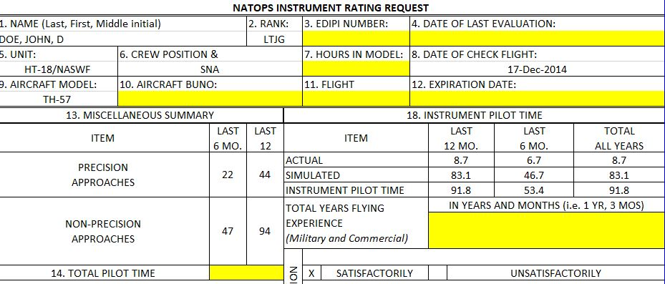
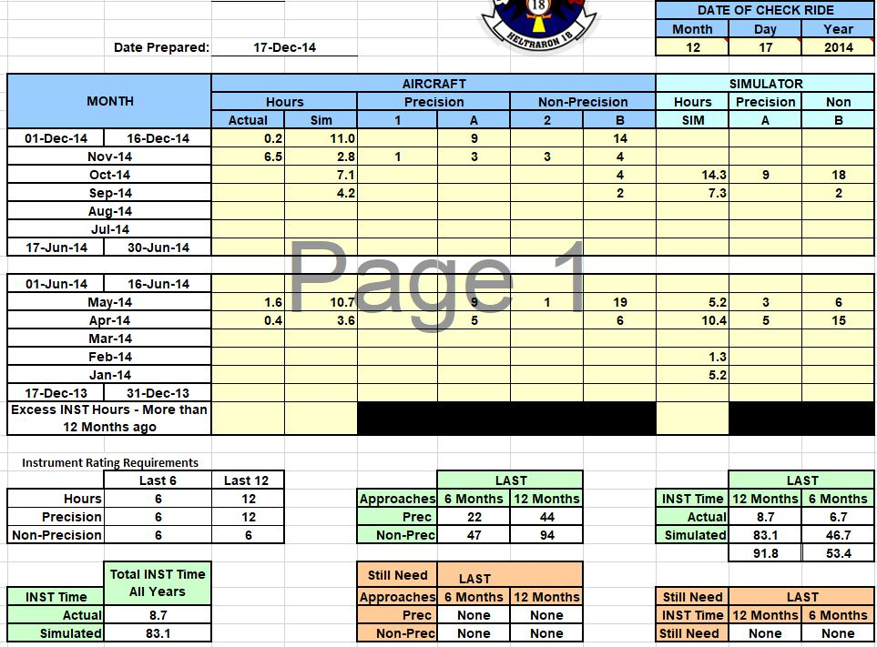
- Take a moment and Check the green arrows. Make sure that all this information transferred over to the Request in the next tab.

- On the Inst Rating Request, all boxes that are yellow needed to be filled in manually.
  - #3 is your DOD IP number.
  - #4, if this if your first Inst check, input “N/A.”
  - #7 is your total hours in the TH-57. Take your TOTAL time subtracted by your T-6B time.
  - #10 Check your log book for that aircraft’s “serial number.”
  - #11 is the flight time of your check ride.
  - #12, it will populate itself. But double check that it is the last day of the month, in the month of your check ride next year.
  - #14 Total time in excluding your INST check.
  - #15, if this is your initial, “N/A.”
  - #16 “Standard.”
  - #17 will be signed by hand later.
  - #18 will self-populate the total year flying experience, based on the date of your first flight.
  - #20 and #26 check with logs and records.
  - #29 and # 30 Last, First, middle initial, and rank of the Inst check evaluating IP
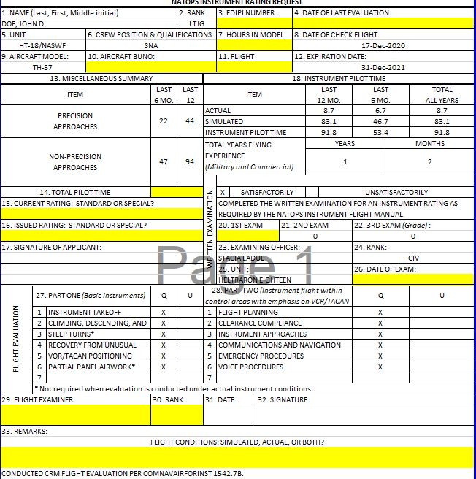
  - #33 Depending on the Inst check’s simulated or actual flight time in your Log Book, Input “Simulated, Actual, or Both.”
- Complete?
  - Place both pages in a yellow folder, along with your I4690 grade sheet, and place the folder back in “folder holder” where you picked up this instruction.
  - LT Regis will review the paperwork and route the request to NATOPS.

